Probability Mix - Probability - Pfeil - Solutions Name:______________________________

Date:______________ Pd:_________
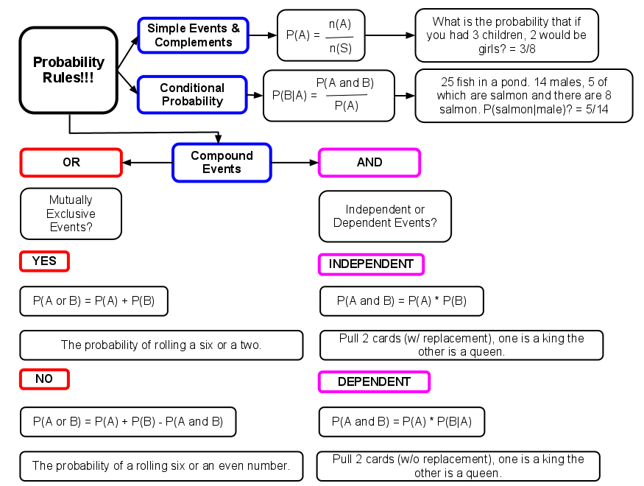

*Not sure where to start? Draw a picture (Venn diagram or tree diagram). At the very least it could provide you with some insight.
*Don’t forget about complements. If P(A) + P(B) = 1, then P(B) = 1 - P(A) … P(B) = P(A^{c})

1) Explain why the following are neither mutually exclusive nor independent.
a) Event A: it’s raining outside Event B: going to a baseball game
Both raining and going to a baseball game can occur at the same time. If it is raining, that will change the probability that I still go to the game.

b) Event A: being a female Event B: being colorblind
Being a female and colorblind can occur at the same time. The majority of colorblind people are males.

2) In a survey, 510 adults were asked if they drive a P(Pickup) = 1/6
pickup truck and if they drive a Ford. The results P(Ford) = 3/10
showed that one in six adults surveyed drives a pickup P(Pickup|Ford) = 2/9
truck, and three in ten adults surveyed drives a Ford.
Of the adults surveyed that drive Fords, two in nine
drive a pickup truck.

a) Find the probability that a randomly selected adult drives a pickup truck given that he or she drives a Ford.
P(Pickup|Ford) = 2/9

b) Are the events of driving a Ford and driving a pickup truck independent or dependent? Show mathematically.
Dependent. If they were independent then P(Pickup) = P(Pickup|Ford). They are not equal.
1/6 ≠ 2/9

c) Find the probability that a randomly selected adult drives a Ford and drives a pickup truck.
P(Ford and Pickup) = P(Ford)*(Pickup|Ford) = (3/10)(2/9) = 6/90

3) A poker player holds a flush when all 5 cards in the hand belong to the same suit. We will find the probability of a flush when 5 cards are dealt.

a) We will concentrate on spades. What is the probability the first card dealt is a spade?
P(spade) = 13/52

b) What is the conditional probability that the second card is a spade, given that the first is a spade?
P(spade|spade) = 12/51

c) Continue in a similar manner to find the probability the third card is a spade, fourth and fifth.
P(3rd) = 11/50 P(4th) = 10/49 P(5th) = 09/48

d) So what is the probability of being dealt a flush of spades?
P(Flush of Spades) = (13/52)(12/51)(11/50)(10/49)(9/48) = 0.000495

e) What is the probability of being dealt a flush?
P(Flush) = 4(.000495) = 0.00198 or (52/52)(12/51)(11/50)(10/49)(9/48) = 0.00198

4) You’re taking a multiple choice exam and you don’t know the answers to two of the questions. Each question has four choices, so the probability of getting a question right by guessing is 0.25. Draw a tree diagram showing the probabilities of getting none, one, or both questions right by guessing.
P(0) = (0.75)(0.75) = 0.5625
P(R) = 0.25
P(W) = 0.75
P(R) = 0.25
P(W) = 0.75
P(R) = 0.25
P(W) = 0.75
P(1) = (0.25)(0.75) + (0.75)(0.25) = 0.375
P(2) = (0.25)(0.25) = 0.0625

5) A sample of automobile dealerships found that 19% of automobiles sold are silver, 22% of automobiles sold are SUVs, and 16% of automobiles sold are silver SUVs. What is the probability that a randomly chosen sold automobile from the sample is silver or an SUV?

Silver (.03)
SUV (.06)
0.16
P(silver) = 0.19 P(SUV) = 0.22 P(silver and SUV) = 0.16
P(silver or SUV) = P(silver) + P(SUV) - P(silver and SUV)
(0.19) + (0.22) - (0.16) = .25

6) Musical styles other than rock and pop are becoming more popular. A survey of college students finds that 40% like country music, 30% like gospel music and 10% like both.
a) What is the conditional probability that a student  likes gospel music if we know that he or she likes country music? | b) What is the conditional probability that a student who does not like country music likes gospel music?
$$P(G|C) = \frac{P(G and C)}{P(C)}=\frac{0.10}{0.40}=0.25$$  P(C)  0.30  P(G)  0.20  0.10 | $$P(G|C^{c}) = \frac{P(G and C^{c})}{P(C^{c})}=\frac{0.20}{0.4+0.2}=0.33$$  P(C)  0.30  P(G)  0.20  0.10  0.4

7) There is a jar that has 5 blue marbles, 6 green marbles, and 3 purple marbles. You close your eyes, reach in the jar and randomly choose 2 marbles. Find the following probabilities:

a) Both are green. b) At least one is purple. c) 1 blue and 1 green.
(6/14)(5/13) = 0.165 1 - (11/14)(10/13) = 0.396 (5/14)(6/13) + (6/14)(5/13)= 0.33
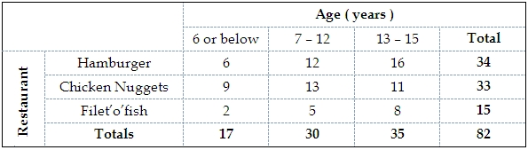
8)

a) Find the probability of being “7-12“ years-old AND preferring “Chicken Nuggets”. (Dep. Events)
P(7-12 and CN) = P(7-12) ∗ P(CN|7-12) = 30/82 ∗ 13/30 = 13/82
b) Find the probability of being “13-15“ years-old OR preferring “Filet’o’fish”. (Not Mutually Exclusive)
P(13-15 or FF) = P(13-15) + P(FF) - P(13-15 and FF) = (35/82) + (15/82) - (8/82) = 0.51
c) Find the probability of preferring “Hamburger” given that the randomly selected child is “13-15” years-old.
P(H|13-15) 16/35 = 0.475 or P(H and 13-15)/P(13-15) = (16/82)/(35/82) = 16/35

d) Show, using probability, that preferring “Hamburger” and being “13-15” years-old are not independent events.
If P(13-15|Hamburger) = P(13-15) then the events are independent. P(13-15|Hamburger) = 16/34 and P(13-15) = 35/82. 16/34 does not equal 35/82 therefore the probabilities are not independent.

