Subjects | Monday | Tuesday | Wednesday | Thursday
Home Reader   |  | Read and record your Home Reader book | Read and record your Home Reader book | Read and record your Home Reader book
Spelling
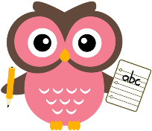

Word Practice


Math
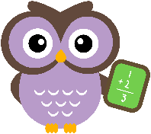

Reminders |  | PE Tomorrow Wear sneakers! | PE Tomorrow Wear sneakers! | Library Tomorrow  Remember your books

- Please read through and complete any and all paperwork to be returned to school.

- Open House Night is scheduled for Tuesday, September 12th. Information will be sent home from the office, please be on the lookout.

- Official homework will begin after Open House. In the meantime, please read with your child for 15 minutes each night.

