- After sign in, select “Continue My Path”
- Select the little blue arrow in the upper left hand corner.
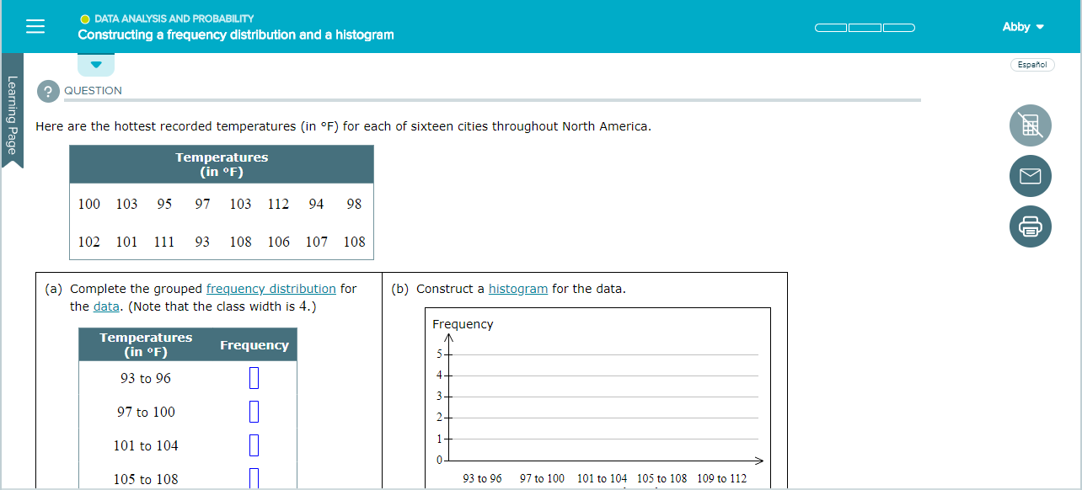
- Students will see topics that they are “Ready to Learn”
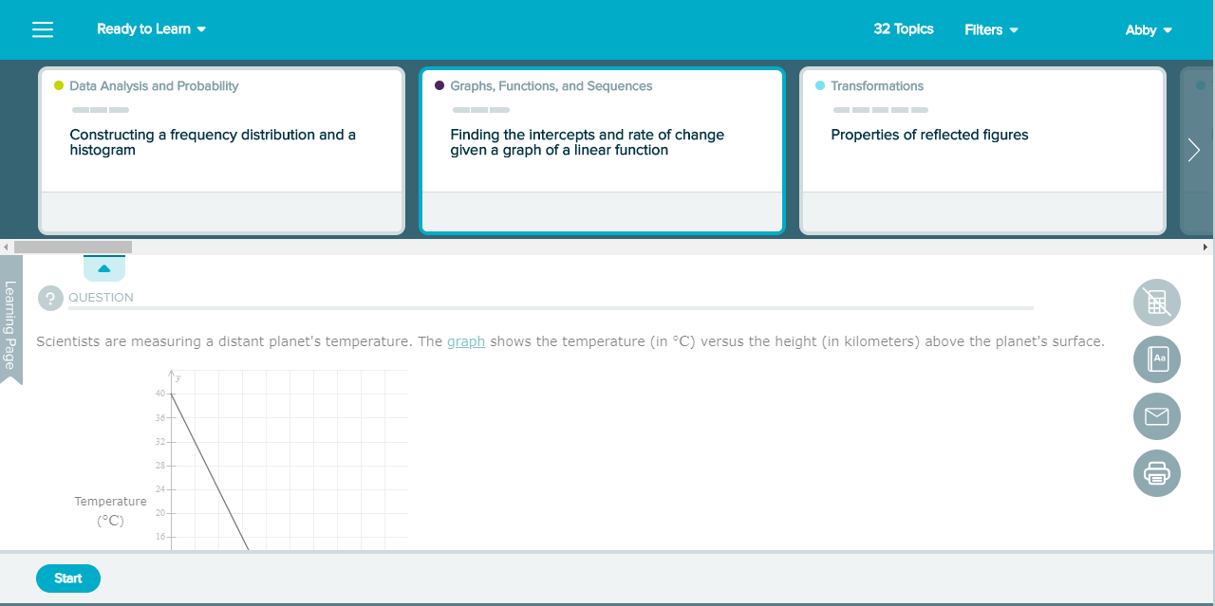
4. Students should select the topic based on their group:
Number System | Whole Numbers and Integers
 | Fractions
 | Decimals
Ratios and Proportions | Ratios, and Proportions, and Measurement
 | Percents
Expressions and Equations | Equations and Inequalities
Statistics and Probability | Graphs, Functions, and Sequences
 | Data Analysis and Probability
Geometry | Lines, Angles, and Polygons
 | Transformations
 | Perimeter, Area, and Volume

