Name:________________________________________________Class & Number ________
Argument Scoring Guide – Buddy Edit/Buddy Name__________________
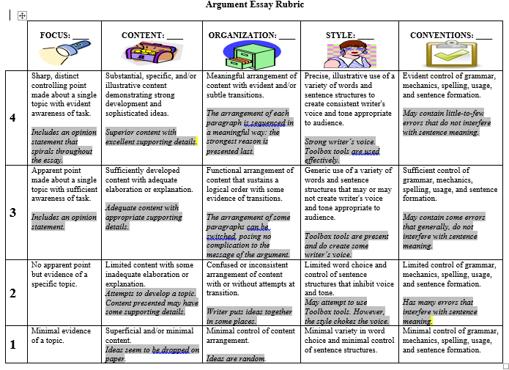
REQUIREMENTS:
_____Five paragraphs (introduction paragraph, three body paragraph, and concluding paragraph)
_____Main point-OPINION STATEMENT is bolded
_____3 reasons stated in the introduction and conclusion. (Your LAST reason should be the MOST IMPORTANT reason) stated in the introduction paragraph - italicized
_____Each reason should have its own paragraph (2nd paragraph: about reason #1, 3rd paragraph: about Reason #2, 4th paragraph: about Reason #3)
_____Minimum three transitions-underlined
_____Minimum three persuasive words or phrases - in red (see chart)
_____An objection – (in parenthesis) an expression or feeling of disapproval or opposition; a reason for disagreeing.
_____Three reasons restated in the concluding paragraph - italicized
_____A call to action (the last sentence in the essay) – in green
_____Toolbox Tools used appropriately
_____Anecdote, statistic, or quote from an expert. Includes a reference noted in the text such as (www.cdc.gov, 2015). Dialogue is optional. Punctuate correctly. Buddy Suggestions: ________________________
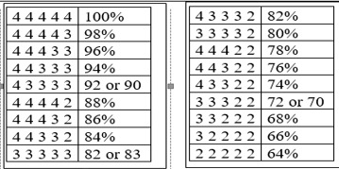
Rubric Score
__________________________________________________
__________________________________________________
________________________________________________
______________________________________________
Name:________________________________________________Class & Number ________
Argument Scoring Guide – Teacher Scoring
REQUIREMENTS:
_____Five paragraphs (introduction paragraph, three body paragraph, and concluding paragraph)
_____Main point-OPINION STATEMENT is bolded
_____3 reasons stated in the introduction and conclusion. (Your LAST reason should be the MOST IMPORTANT reason) stated in the introduction paragraph - italicized
_____Each reason should have its own paragraph (2nd paragraph: about reason #1, 3rd paragraph: about Reason #2, 4th paragraph: about Reason #3)
_____Minimum three transitions-underlined
_____Minimum three persuasive words or phrases - in red (see chart)
_____An objection – (in parenthesis) an expression or feeling of disapproval or opposition; a reason for disagreeing.
_____Three reasons restated in the concluding paragraph - italicized
_____A call to action (the last sentence in the essay) – in green
_____Toolbox Tools used appropriately
_____Anecdote, statistic, or quote from an expert. Includes a reference noted in the text such as (www.cdc.gov, 2015). Dialogue is optional. Punctuate correctly. Teacher Comments: ________________________
Rubric Score
__________________________________________________
__________________________________________________
________________________________________________
______________________________________________

